**M/s. SYBER SOFT**

*National Youth Computer Training Academy*.

Sutahata, Purba Medinipur, PIN – 721635

✆ 8001937525, e-mail : cybersoft2011@gmail.com

___________________________________________________________________________________________________________________________________

**COMPUTER TRAINING DIVISION**

Mouse : Lett Button, Right Button

Go to Start => All Programs => Microsoft Office => Microsoft **Word** 2010 (Click the Left button of Mouse)

This Window will be appear on your Monitor ☟

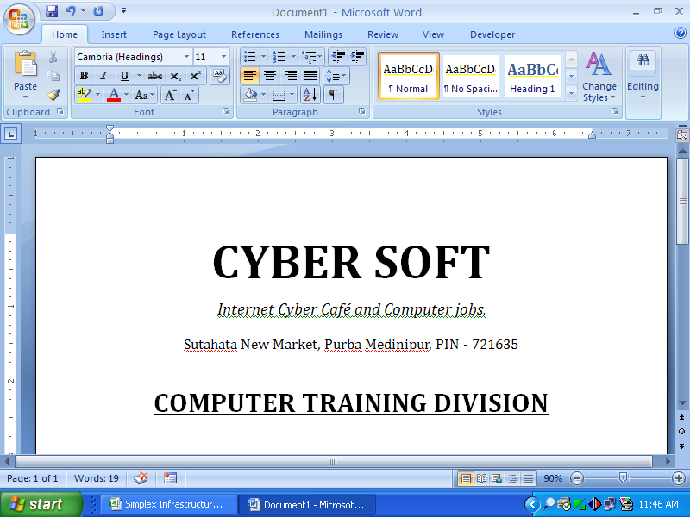

***About Type and Key Board*** :

Alphabet Key : A to Z

Numeric Key : 0 to 9

Functional Key : F1 to F12

Special Key : Ctrl, Alt, Enter, Shift, Backspace, etc.

Screen Control Key : Up Arrow, Down Arrow, Left Arrow, Right Arrow, Page up, Page down etc.

Caps Lock, Shift, Back Space, Del

Ctrl. Alt Up Arrow Down Arrow Left Arrow Right Arrow

* **To save a new file** :

*Step 1* : Click on Office Button, Scroll down to Save and Click on **Save**. (appear this)

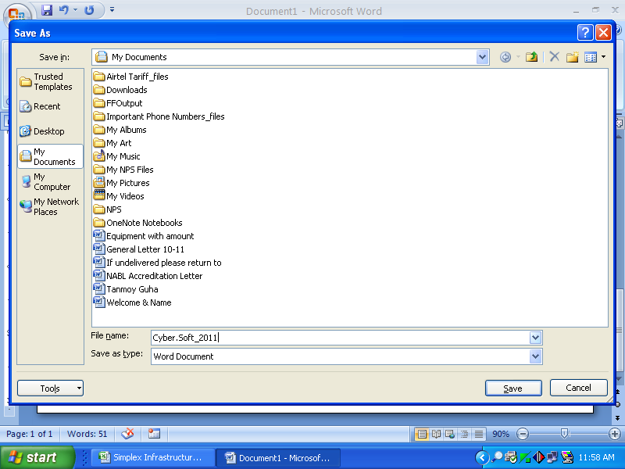

*Step 2* : Type the “**File name**” in the field which you wand and look the “Save in” field (Target folder.)

*Step 3* : Then Click on the “**Save**” button again.

* **To Close a file** : Click on Office Button, Scroll down to Close and Click on **Close**. Save before close
* **To open an existing file** :

*Step 1* : Click on Office Button, Scroll down to Open and Click on **Open**. (appear this)

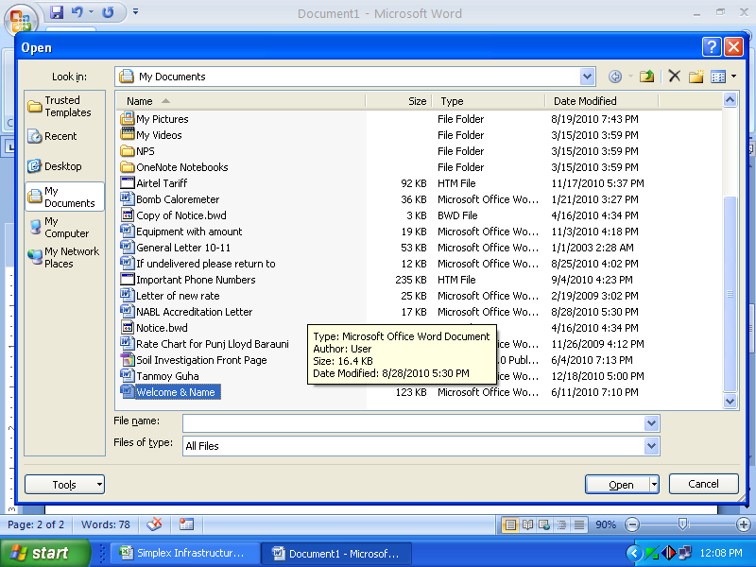

*Step 2* : Select the file name from file list which you want to open.

*Step 3* : Then Click on **Open** again.

* **To create a new file** :

*Step 1* : Click on Office Button, Scroll down to New and Click on **New**

Auto Select the Blank Document.

*Step 2* : Then Click on **Create** again.

* **To Exit from M.S. Office** :

Click on Office Button, Scroll down to Exit Word and Click on **Exit Word. OR Click on Cross**